Mini Project Report: Stroke Risk Analysis
Prepared by: Ashi Gigi
Batch: DA39
1. Project Objective
The objective of this project is to analyze a healthcare dataset to understand the factors that contribute to stroke risk. The dataset includes patient demographics, health indicators, and lifestyle information. The goals are:
- Identify patterns in stroke occurrence.
- Understand how age, BMI, glucose levels, smoking status, and other factors influence stroke risk.
- Prepare the dataset for analysis by cleaning missing and inconsistent data.
- Visualize key insights in Power BI to support healthcare decision-making.
2. DataSet URL:- https://www.kaggle.com/datasets/fedesoriano/stroke-prediction-dataset?utm_source=chatgpt.com
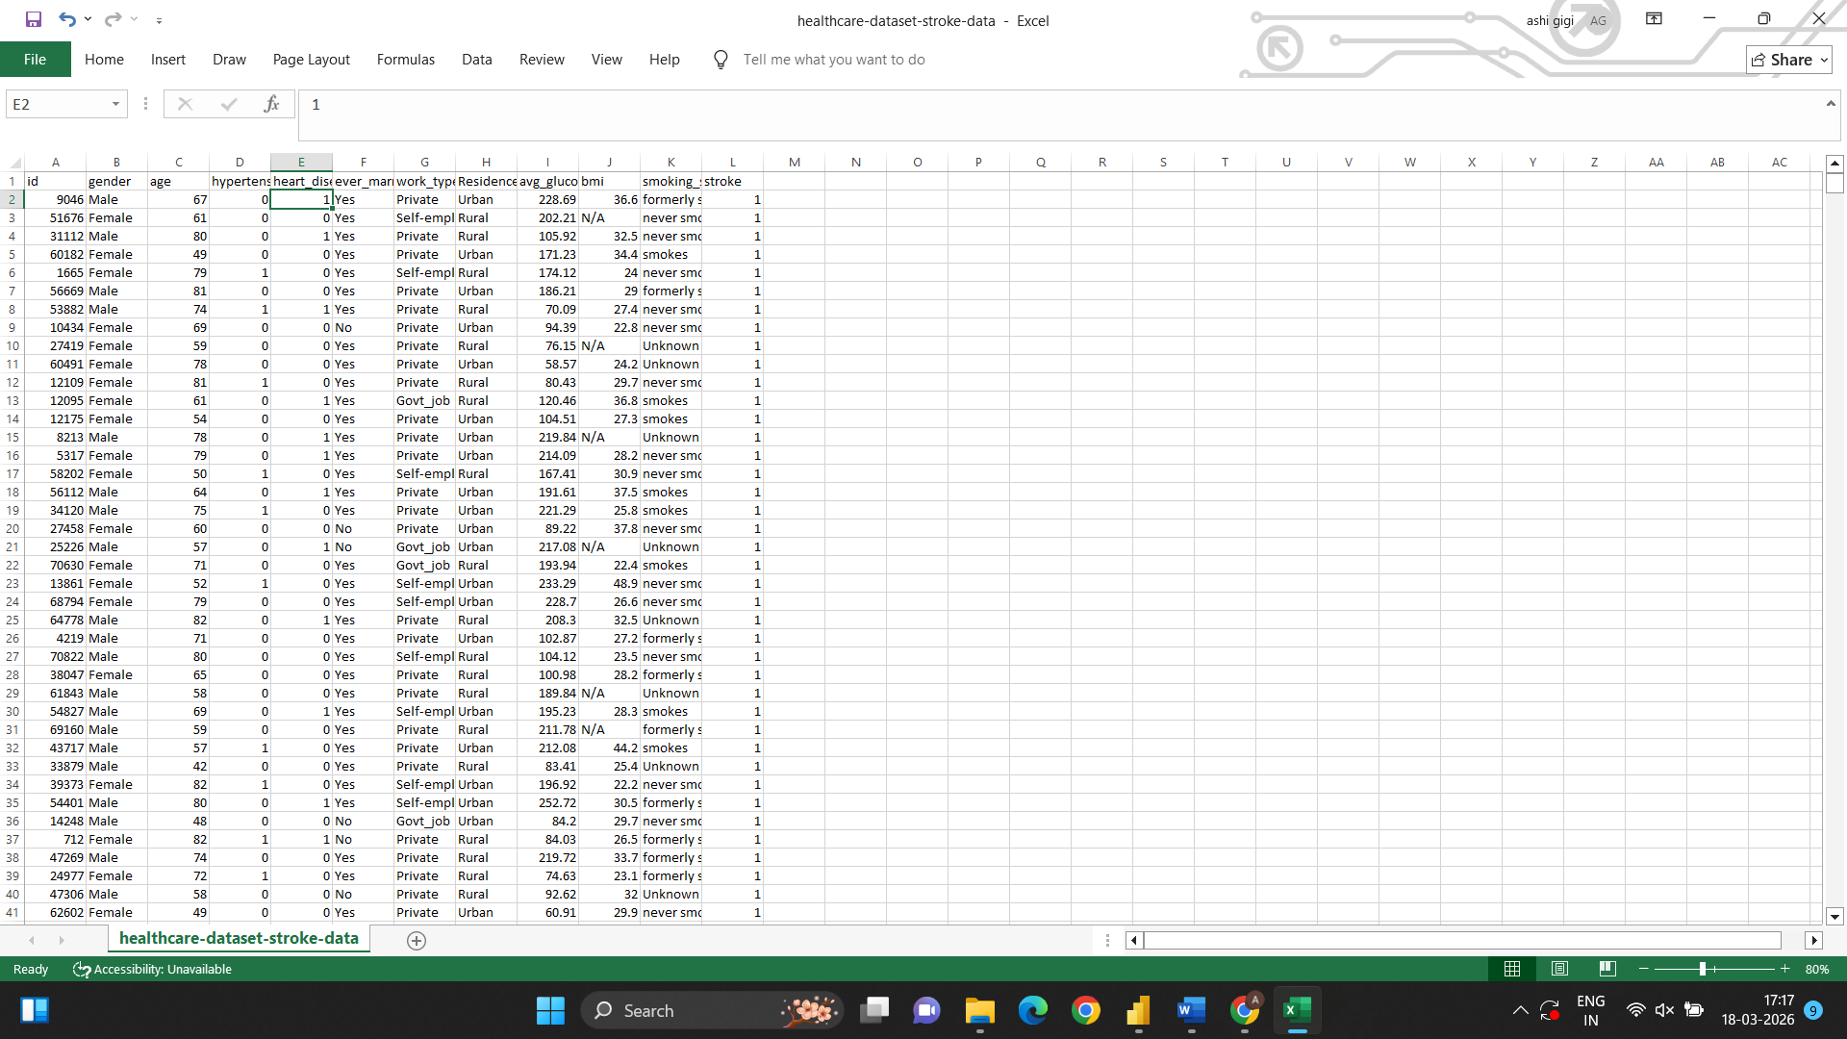
3. DATA CLEANING
Step 1: Handle Missing Values
Identify missing or blank values using:=COUNTBLANK(J:J) (or relevant columns
Handle missing data appropriately:
- Numeric columns (e.g., BMI):
Replace missing values with the column mean (average) to maintain data consistency.
- Categorical columns (e.g., smoking_status, work_type):
Replace missing values with "Unknown" to avoid data loss and maintain category structure.
Step 2: Fix Inconsistent Data
- Standardize text values to ensure uniformity:
Male / male → Male
formerly smoked → Formerly Smoked
Ensure consistent capitalization and spelling across all categorical columns.
- Identify and correct invalid numeric entries:
Remove or fix negative BMI values or unrealistic entries.
Step 3: Remove Duplicates
- Use the ID column as the primary reference to detect duplicates.
- This ensures each record represents a unique individual.
Step 4: Create Categories from Continuous Values
To improve analysis and visualization, convert continuous variables into meaningful categories:
- Age Group:
  - Child
  - Adult
  - Middle Age
  - Senior
- BMI Category:
  - Underweight
  - Normal
  - Overweight
  - Obese
- Glucose Level Category:
  - Normal
  - Prediabetes
  - Diabetes
These categorizations help in identifying trends and patterns more clearly in analysis.
Step 5: Format Columns
- Ensure correct data types:
  - Numeric columns → Number format
  - Categorical columns → Text format
Improve readability:
- Round values like BMI and glucose levels to 1–2 decimal places.
- Check for consistency across all columns before importing into tools like Power BI.
4. FINAL DATASET
- Cleaned and structured dataset saved as Excel
- Ready for Power BI analysis

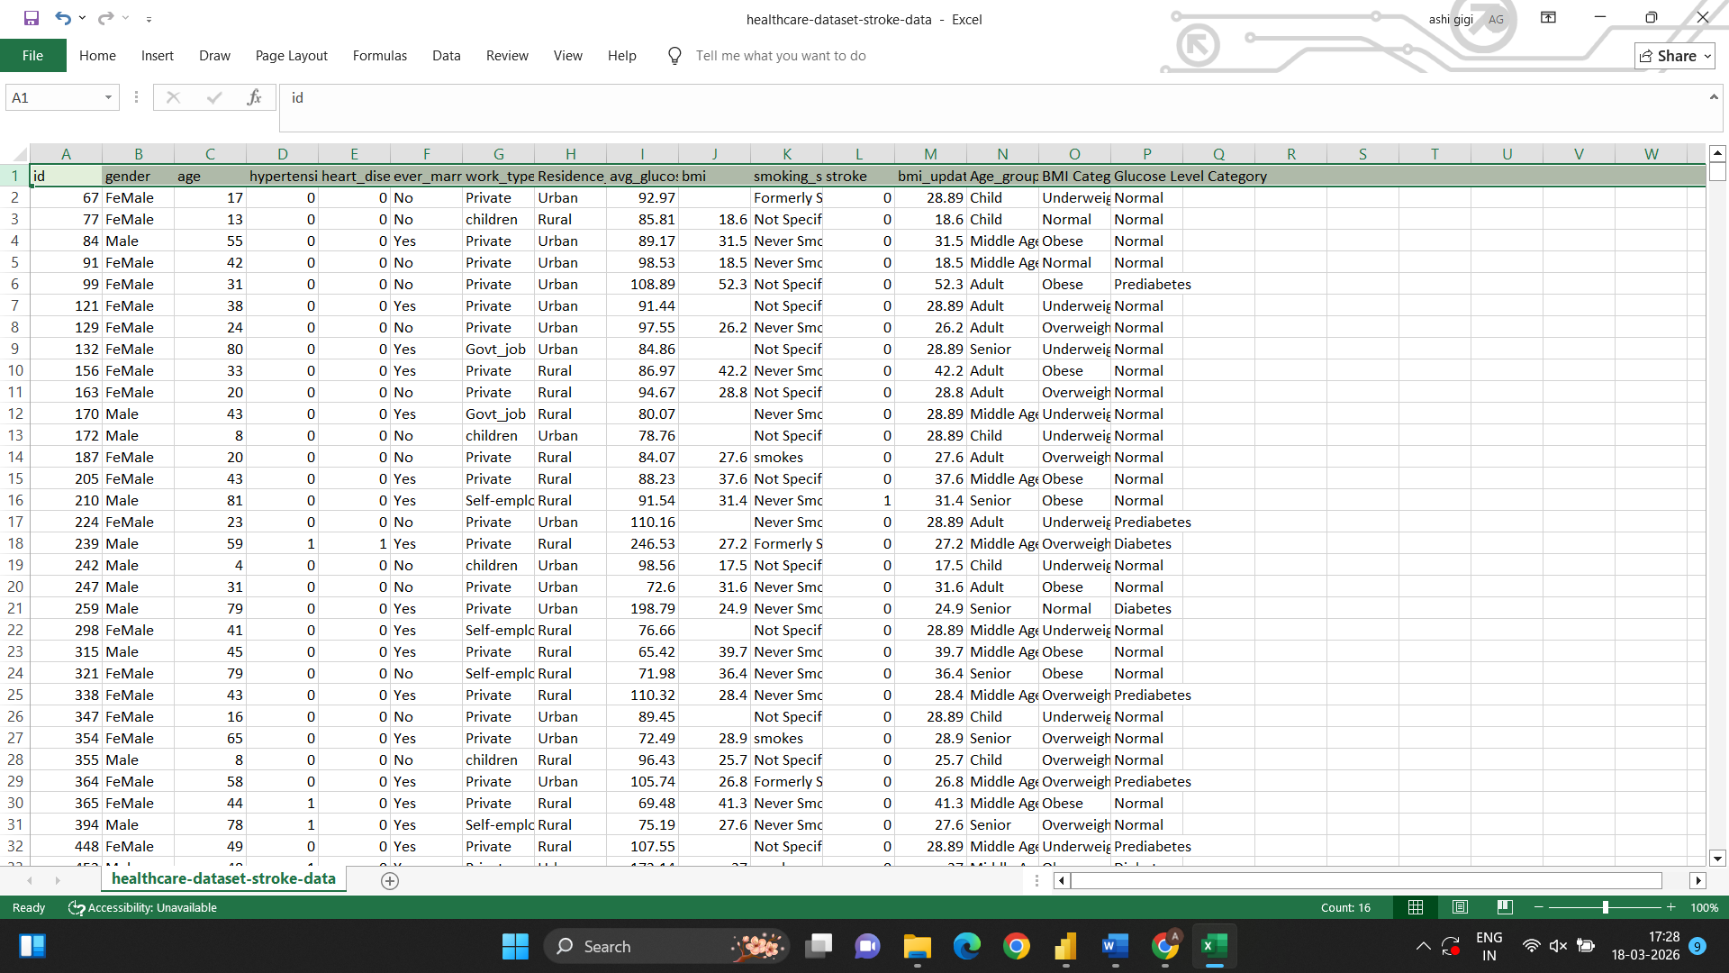

5.Data Upload to Power BI

6. Data Transformation in Power BI
Step 1: Verify Data Types
- Age → Number
- BMI → Decimal
- Stroke → Whole Number
Step 2: Create Measures:-
Total Patients = COUNTROWS('healthcare-dataset-stroke-data')
Stroke Cases = CALCULATE(COUNTROWS('healthcare-dataset-stroke-data'), 'healthcare-dataset-stroke-data'[stroke] = 1)
Stroke Rate = DIVIDE([Stroke Cases], [Total Patients])
Step3: Create Column:-Stroke Status
Converted binary values into readable categories by using:- =IF('healthcare-dataset-stroke-data[stroke]=1,"Stroke","No Stroke")
  - 0 → No Stroke
  - 1 → Stroke
Step4: Create Hierarchies
Demographic Hierarchy (Age Group → Gender):-A hierarchy was created combining for to analyze stroke distribution across age groups and further break it down by gender and enables drill-down functionality (e.g., Senior → Male/Female)
  - Age Group
  - Gender
Stroke Status Hierarchy:-A hierarchy was created for to easily compare stroke vs non-stroke cases across different categories and helps in better visualization using stacked and drill-down charts
  - Stroke
  - No Stroke
7.Dashboard Creation
7.1 KPI Section
Created Card visuals:
- Total Patients
- Stroke Cases
- Stroke Rate
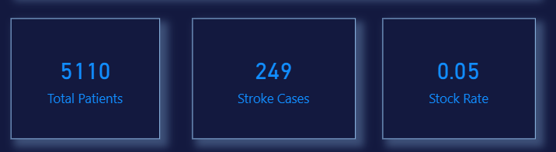

7.2 Stroke Distribution
- Pie Chart
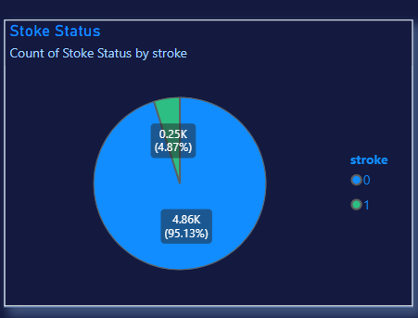

7.3 Demographic Analysis
Stroke by Age Group
- Clustered Column Chart
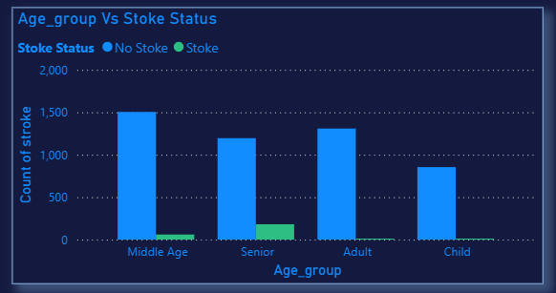
- The Middle Age group has the highest number of individuals overall, but relatively few stroke cases.
- The Senior group shows a significantly higher number of stroke cases compared to other age groups.
- Adults have moderate counts but very low stroke occurrence.
- Children show minimal stroke cases, indicating very low risk.
Stroke occurrence increases with age, with seniors being the most affected group.

Stroke by Gender
- Clustered Bar Chart
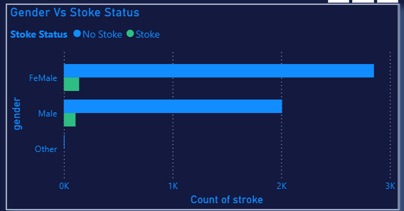
- Females have the highest total count, followed by males.
- Stroke cases are slightly higher in females compared to males.
- The “Other” category has very few records, making it less significant for analysis.
Stroke affects both genders, but a slightly higher occurrence is observed among females in this dataset.
Stroke by Marital Status
- 100% Stacked Bar Chart
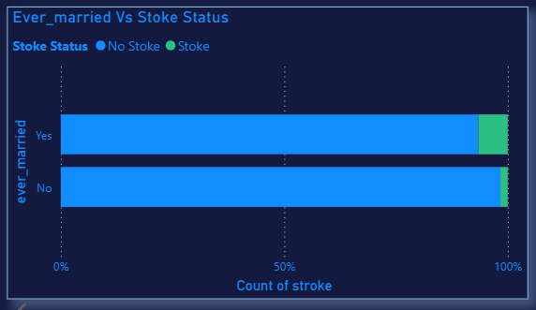

- The Senior group has the highest number of stroke cases by a large margin.
- The Middle Age group has the second-highest count.
- Adults and Children have very low stroke cases.
Age is a major risk factor, with stroke cases increasing sharply in older populations.

7.4 Health Analysis
Hypertension vs Stroke
- Clustered Column Chart
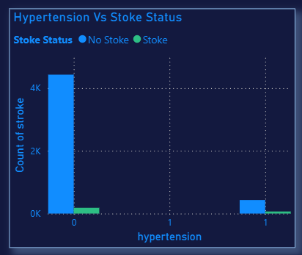
- People with hypertension have more stroke cases than those without.
- Most people don’t have hypertension, so their total count is higher.
Hypertension increases stroke risk.

Heart Disease vs Stroke
· Clustered Bar Chart
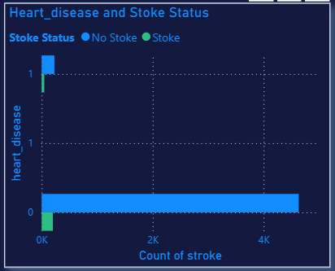
- People with heart disease show more stroke cases.
- Those without heart disease have fewer stroke cases.
Heart disease is linked to higher stroke risk.

BMI Category vs Stroke
- Stacked Column Chart
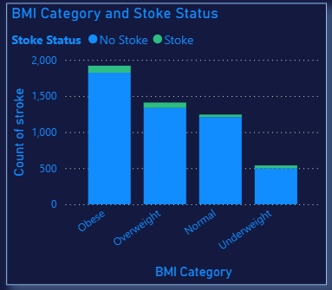
- Obese and overweight groups have more stroke cases.
- Underweight has the lowest stroke cases.
Higher BMI increases stroke chances.

Glucose Category vs Stroke
- Line Chart
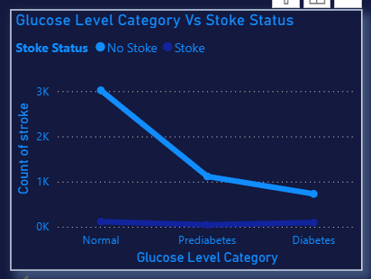
- Diabetes group has more stroke cases compared to normal.
- Stroke cases increase as glucose level increases.
High glucose levels increase stroke risk.

7.5 Lifestyle Analysis
Smoking vs Stroke
- Stacked Bar Chart
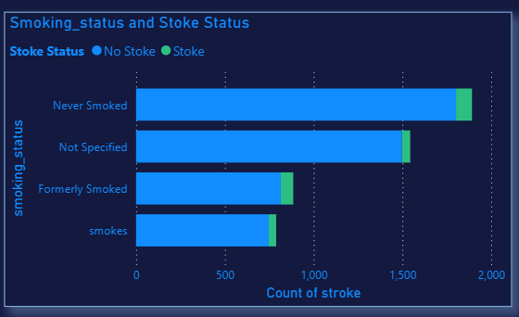

- Smokers and formerly smokers show higher stroke cases.
- Even never smokers have cases due to other risk factors.
- “Not specified” has moderate cases.
Smoking increases stroke risk, but it’s not the only factor.

Work Type vs Stroke
- Clustered Column Chart
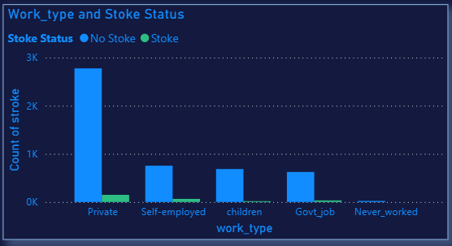
- People working in the private sector have the highest number of stroke cases.
- Other work types (self-employed, govt job) show fewer cases.
- Very few cases in “never worked” and children.
Stroke cases are more common among working adults, especially in private jobs.

7.6 Location Analysis
Urban vs Rural
- Donut Chart
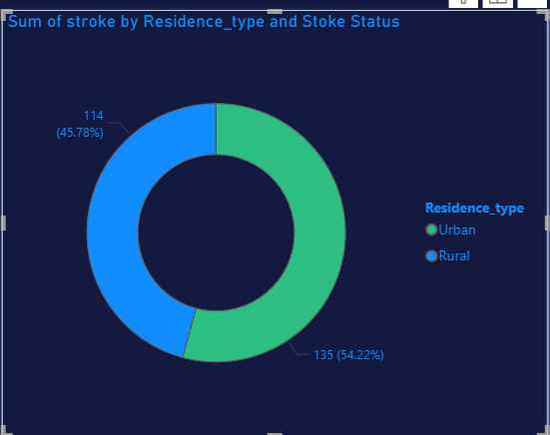
- Urban areas have slightly more stroke cases than rural areas.
- The difference is small but noticeable.
Stroke is slightly more common in urban populations.

7.7 Filters (Slicers)
Added slicers for:
- Demographic Hierarchy
- Stock Status Hierarchy
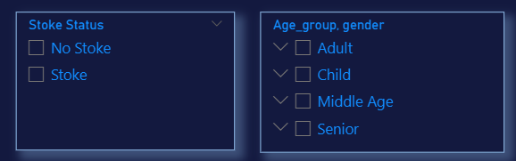
8. Key Insights
- Stroke cases increase significantly with age
- Patients with hypertension and heart disease show higher stroke risk
- Higher BMI and glucose levels are associated with stroke
- Lifestyle factors like smoking impact stroke occurrence
- Most patients do not experience stroke, making percentage analysis important

9. Conclusion
This project successfully demonstrates how healthcare data can be cleaned, analyzed, and visualized to extract meaningful insights. The Power BI dashboard helps identify key stroke risk factors and supports data-driven decision-making in healthcare.

